VPC Challenge

Use Case: Setting up Transit Gateway and VPC Endpoints for a Multi-VPC Architecture

Scenario:

A large organization is migrating its on-premises infrastructure to the AWS cloud.

The organization's architecture involves multiple VPCs for different departments and applications,

each requiring secure communication with centralized services and external resources.

The IT team needs to design and implement a scalable and efficient network architecture to accommodate

the organization's growth and ensure robust connectivity between VPCs and external services.

Objectives:

Design and deploy a scalable network architecture using AWS Transit Gateway to simplify network connectivity between multiple VPCs.

Configure VPC endpoints to securely access AWS services without internet gateways or NAT gateways, ensuring data privacy and minimizing exposure to external threats.

Step 1: Create 4 VPC’s in different regions N.Virginia, Ohio, California,Oregon

With CIDR: 20.0.0.0/16

21.0.0.0/16

22.0.0.0/16

23..0.0.0/16

Step 2: Create Subnets for 4 VPC’s

Step 3: Create Internet gateway for 1VPC only

Step 4: Create RT for All 4VPC’s

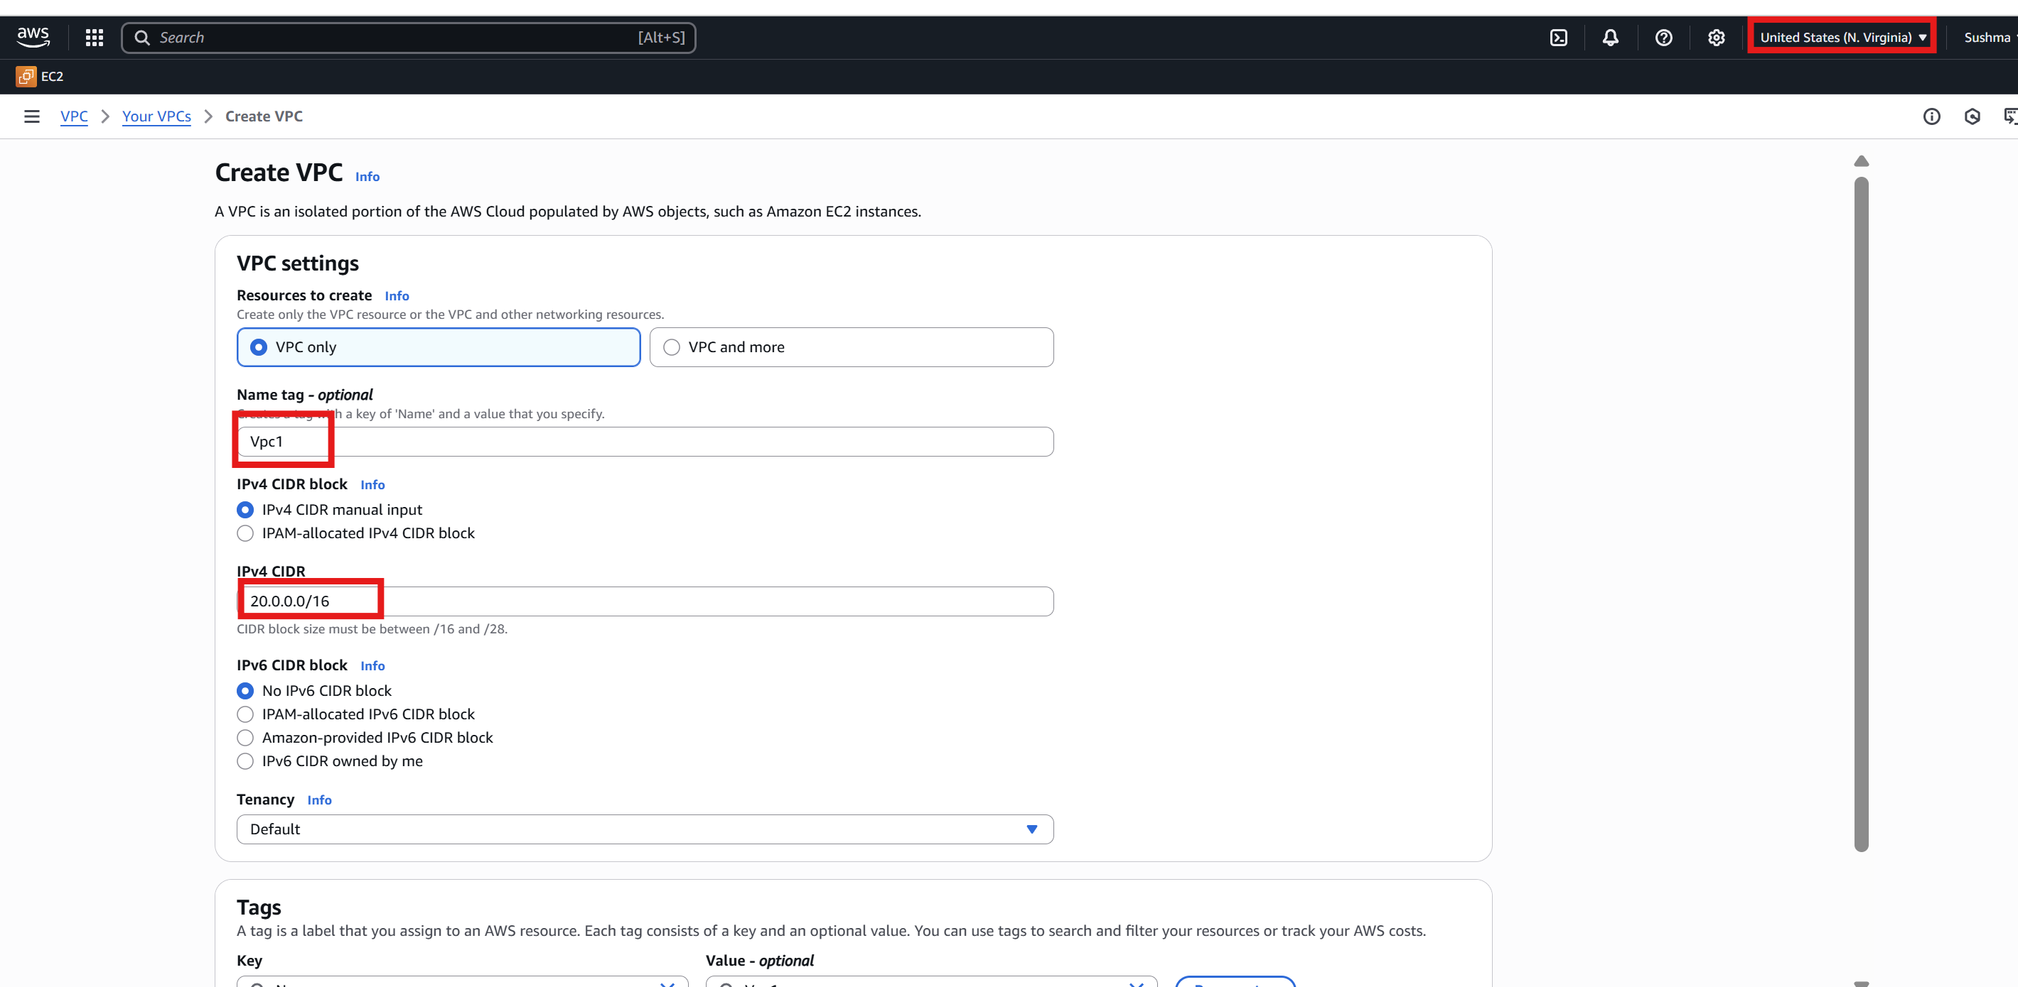

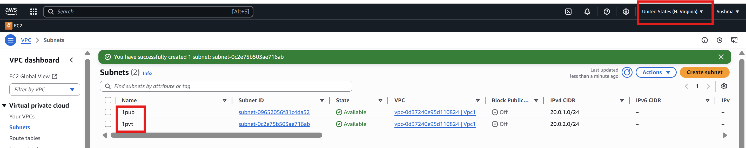

IGW

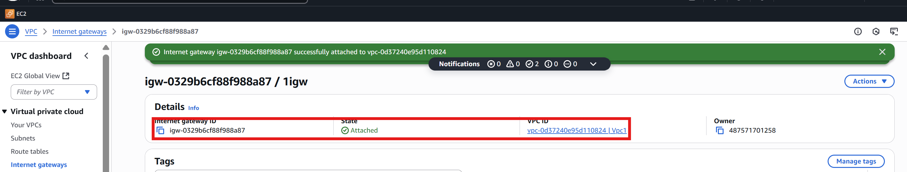

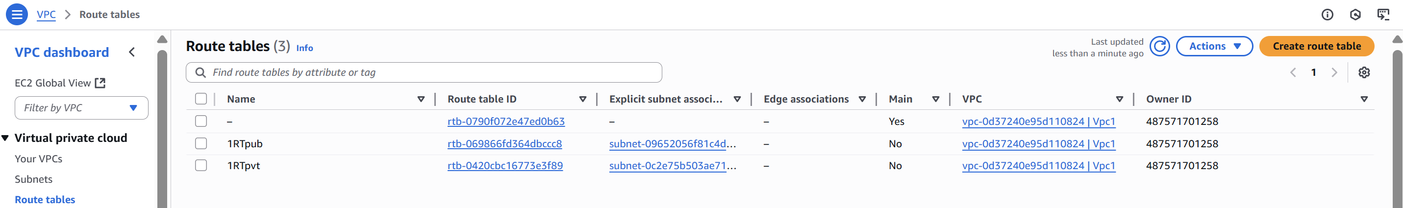

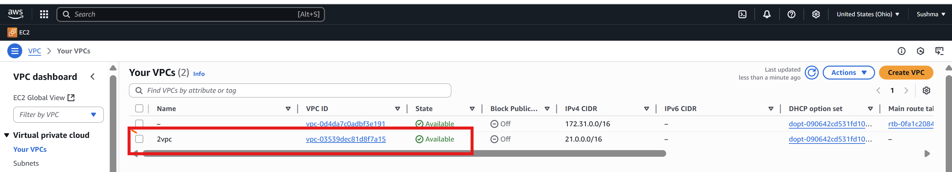

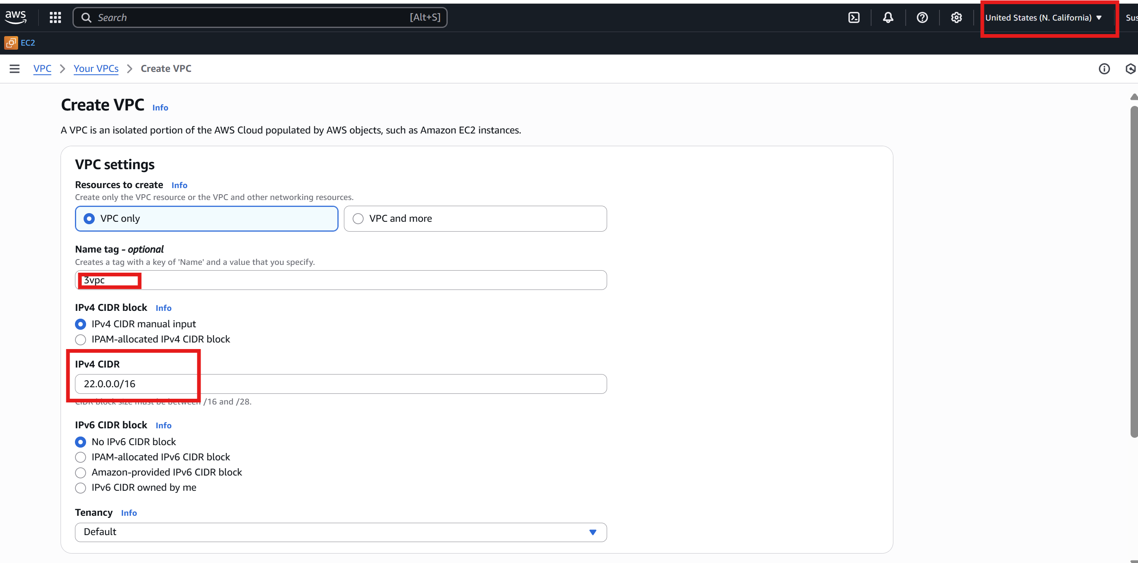

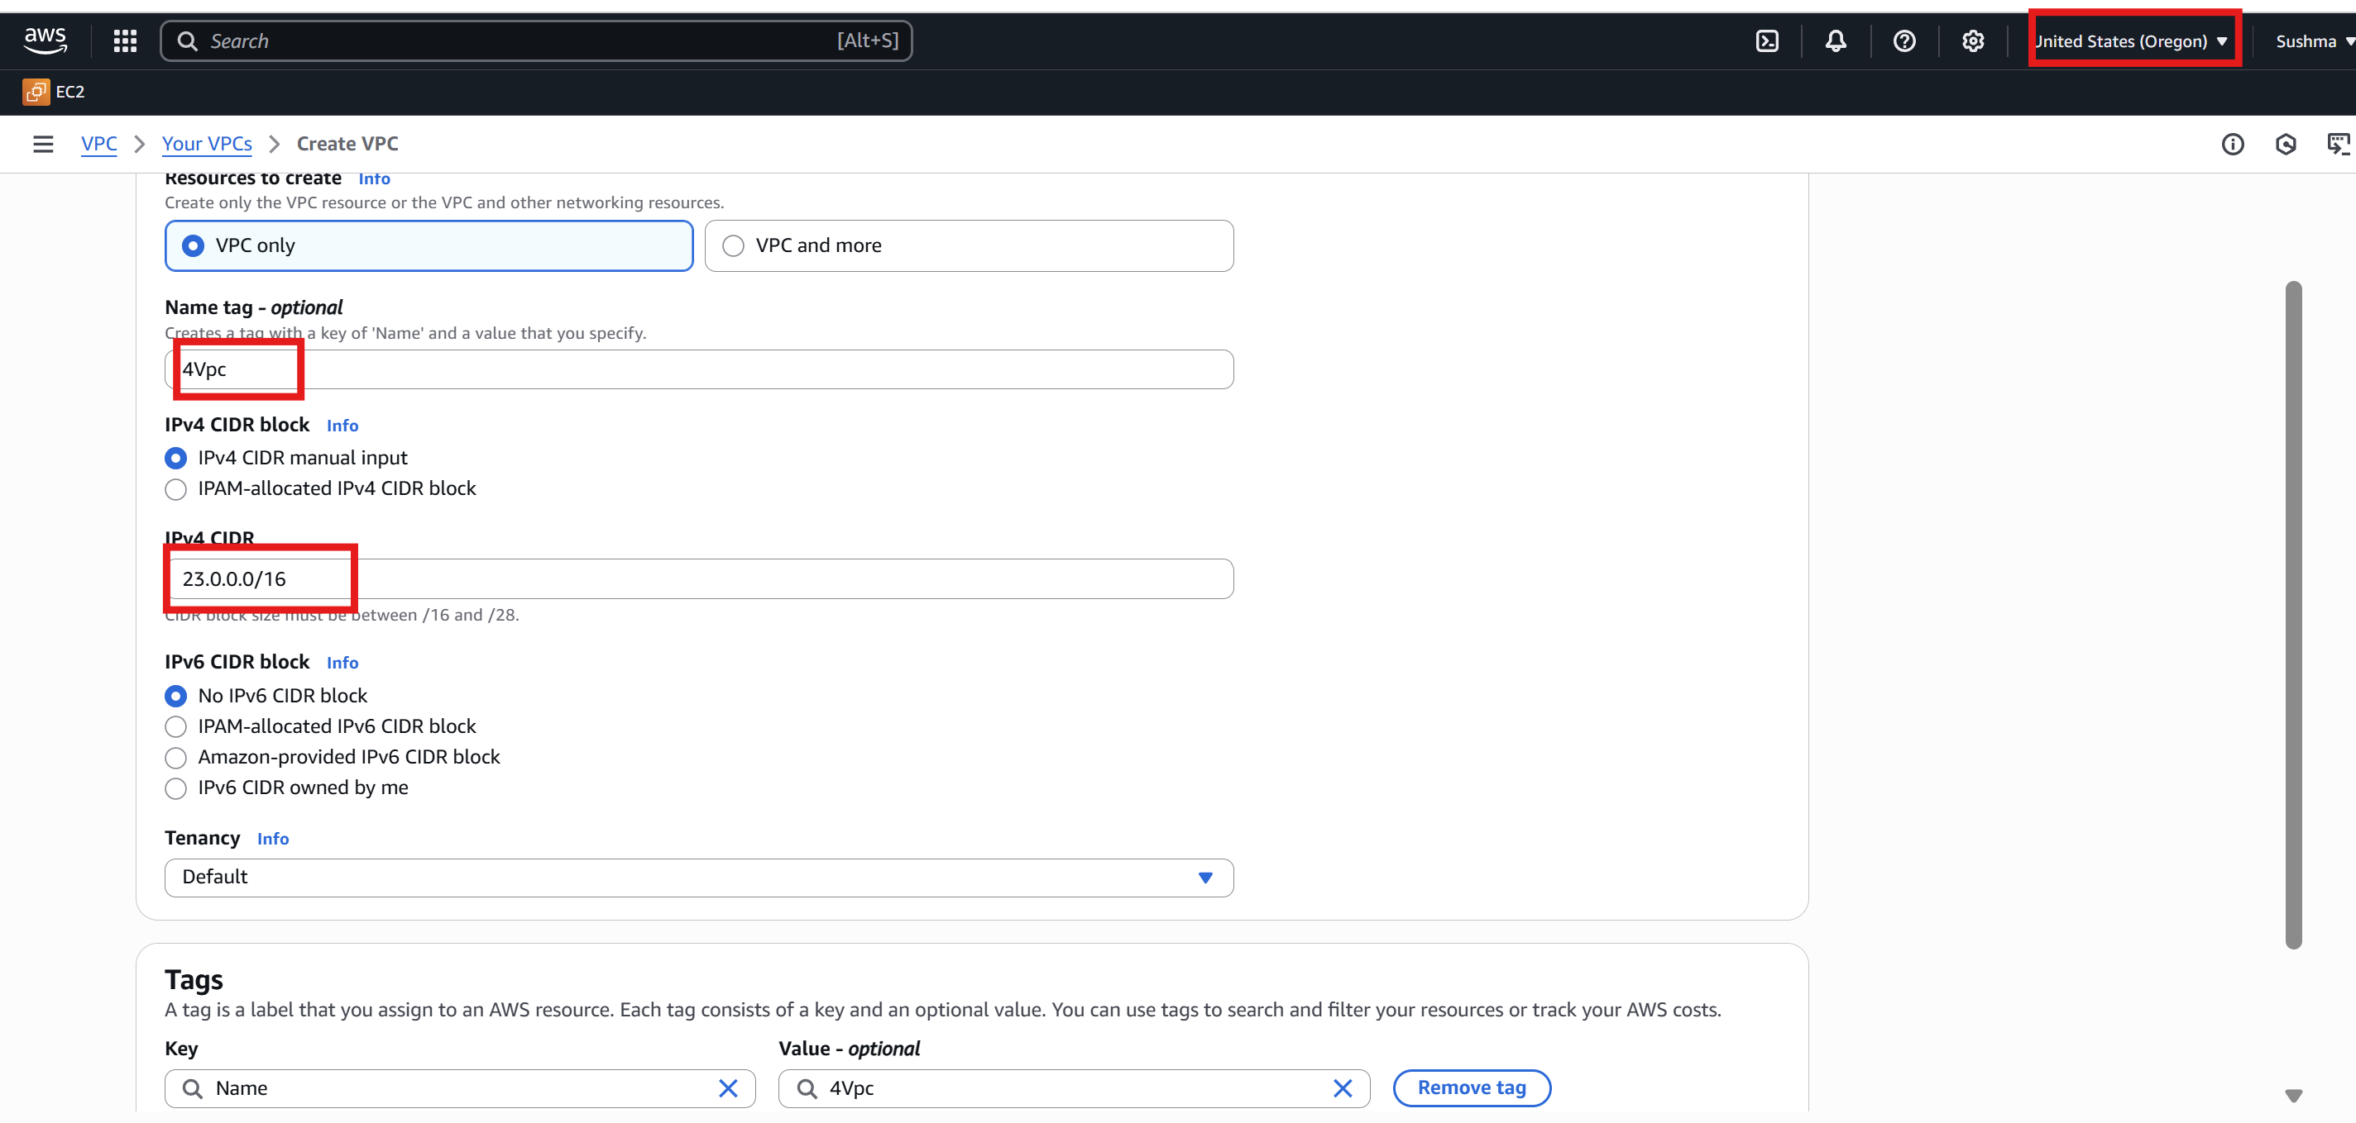

Step 5: Create Transit Gateway in all VPC’s

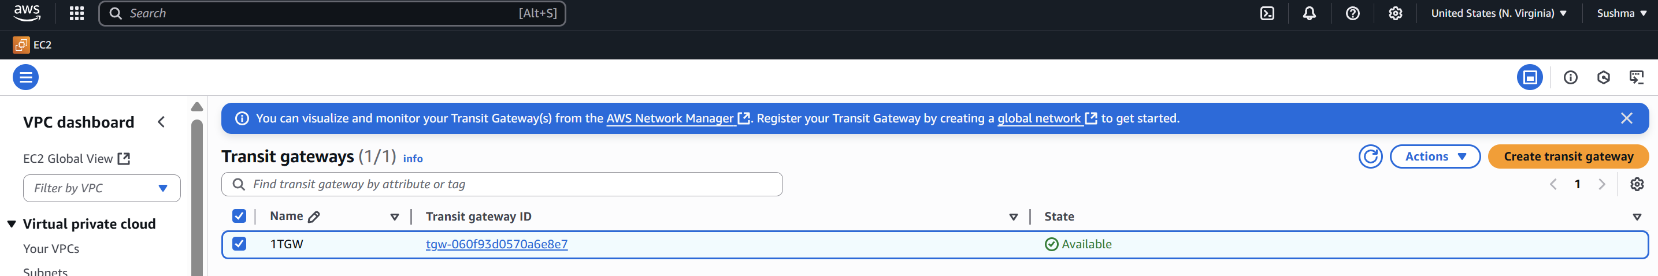

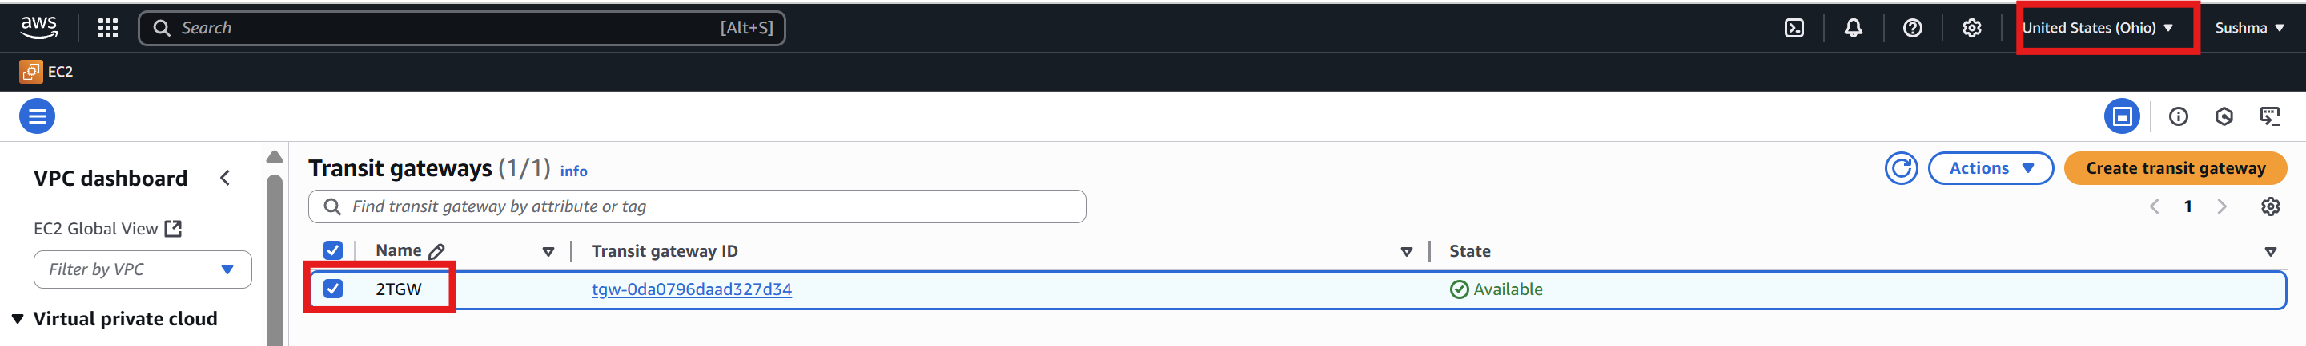

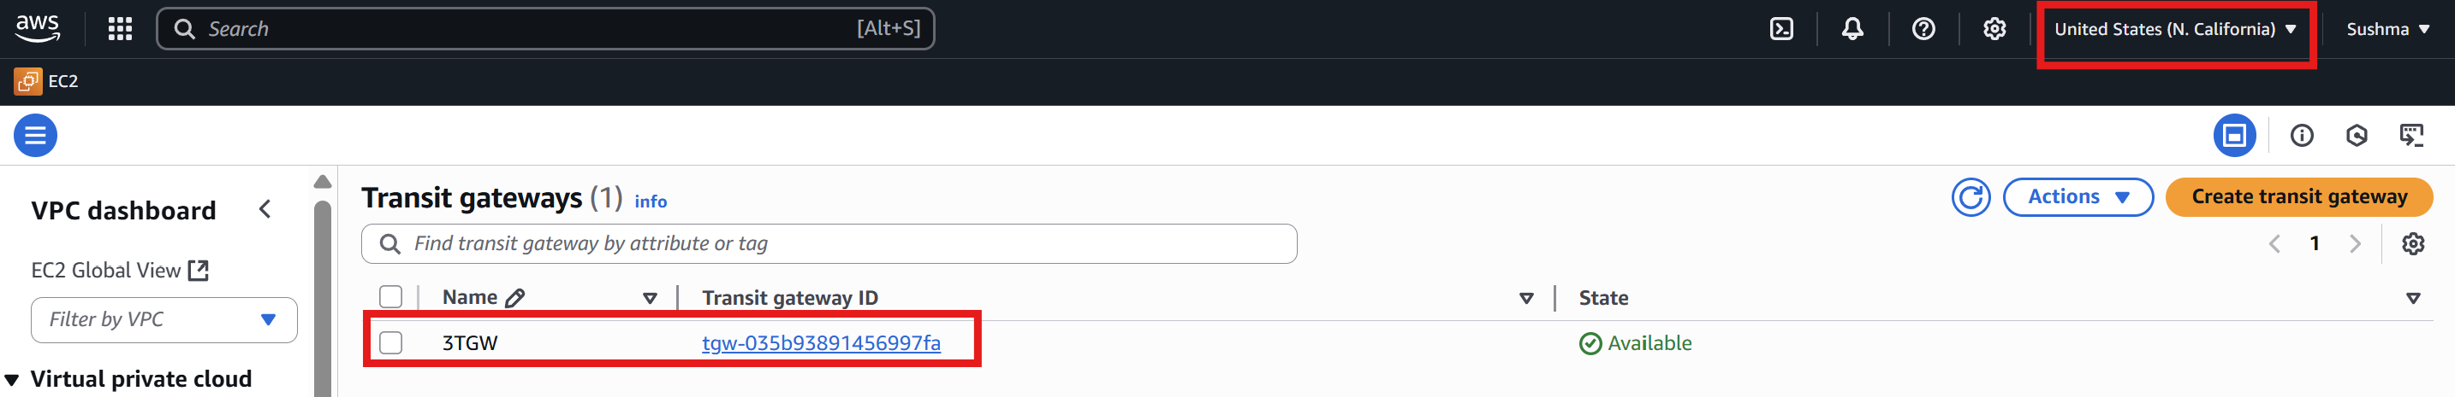

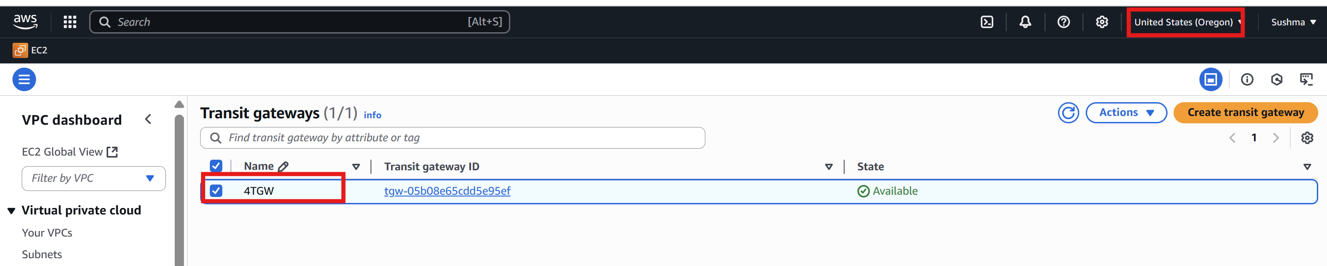

Step 6: Create transit gateway attachments from 1st VPC to other VPC’s

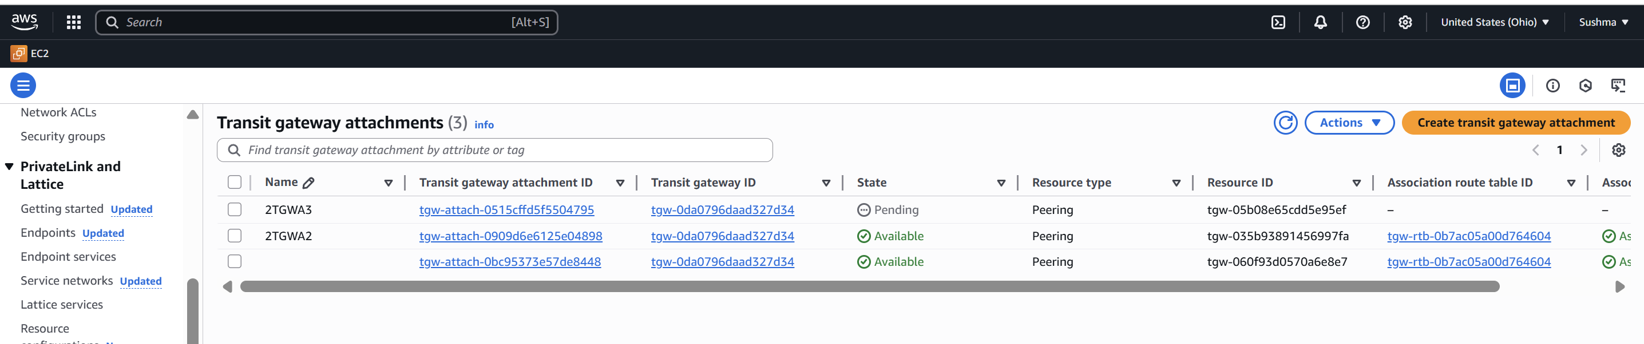

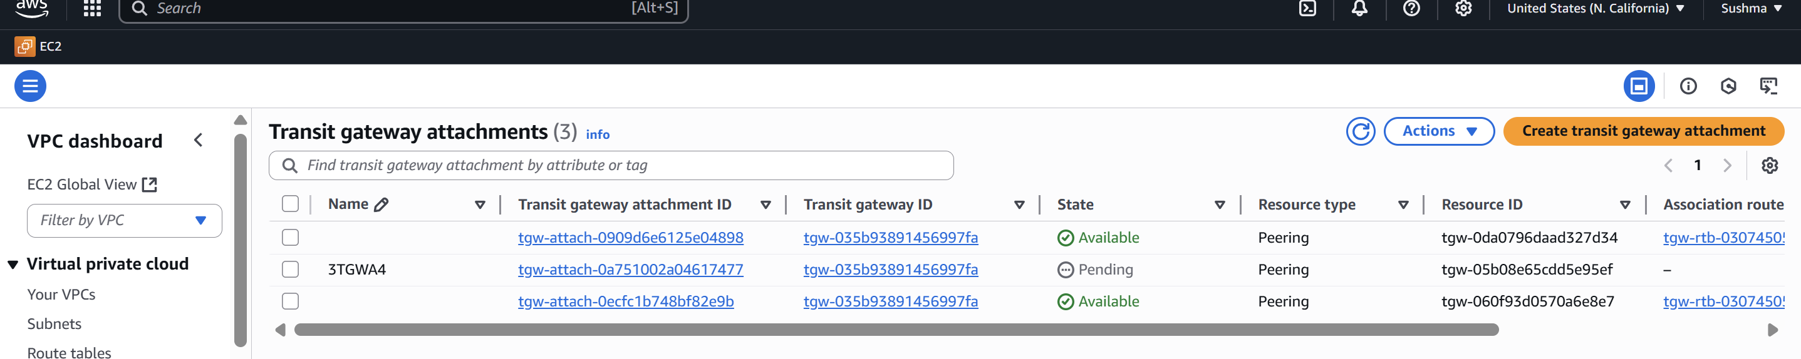

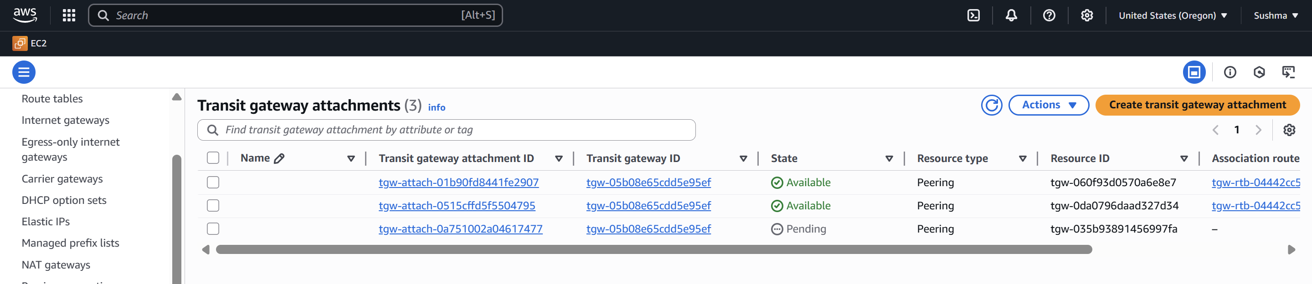

Step 7:Create end points in 2nd,3rd and 4th VPC’s and attach them into PVT RT.

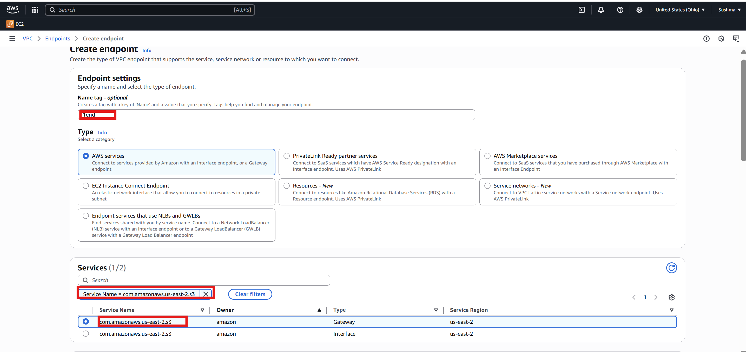

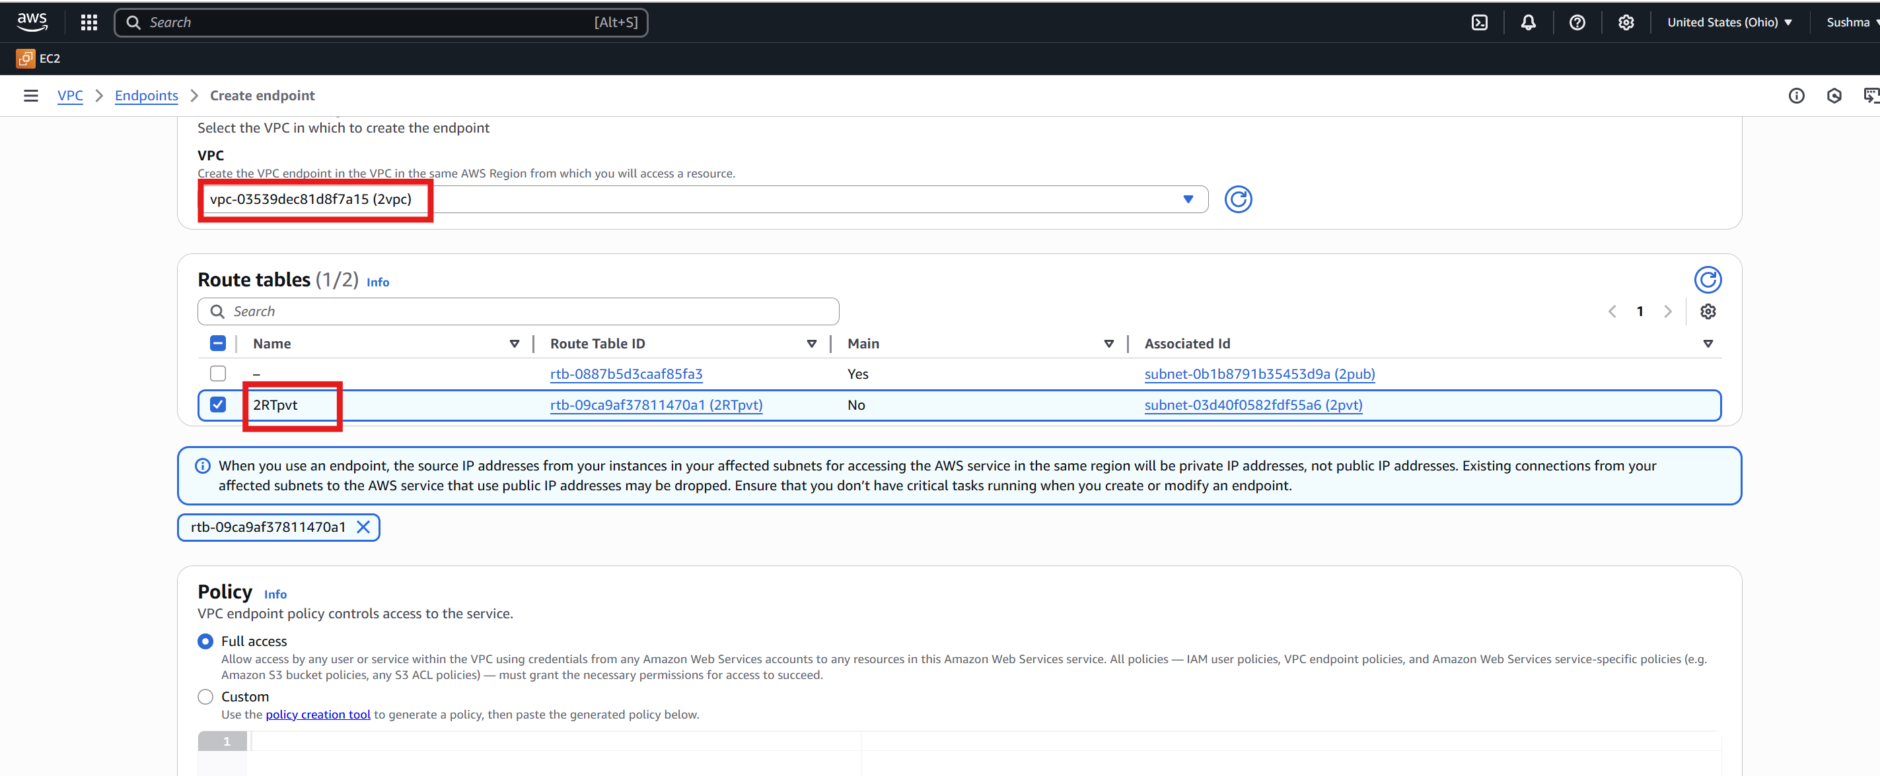

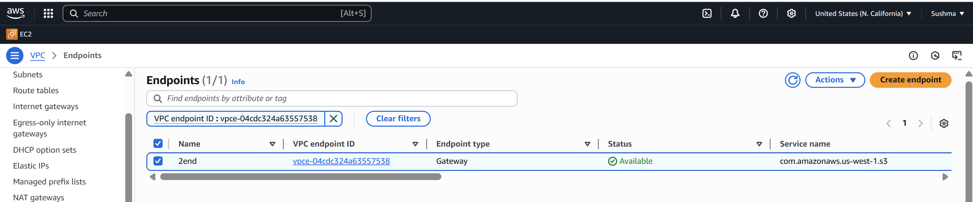

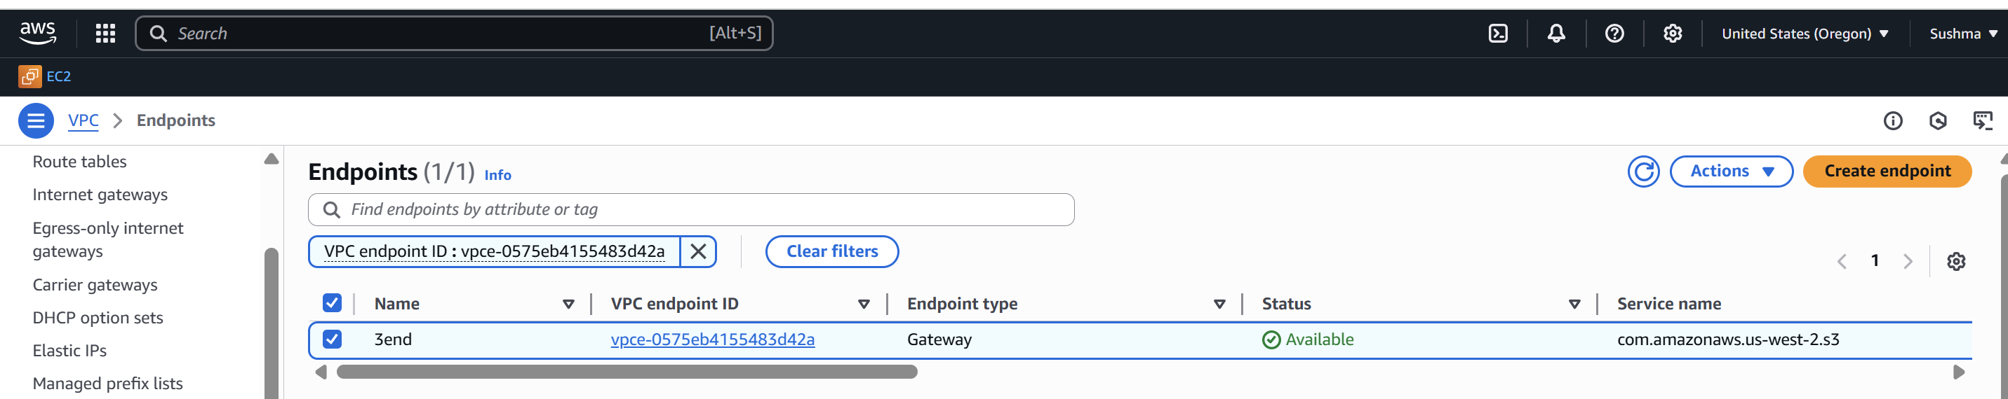

Step 7:Go to Transitgate way RT and add routes

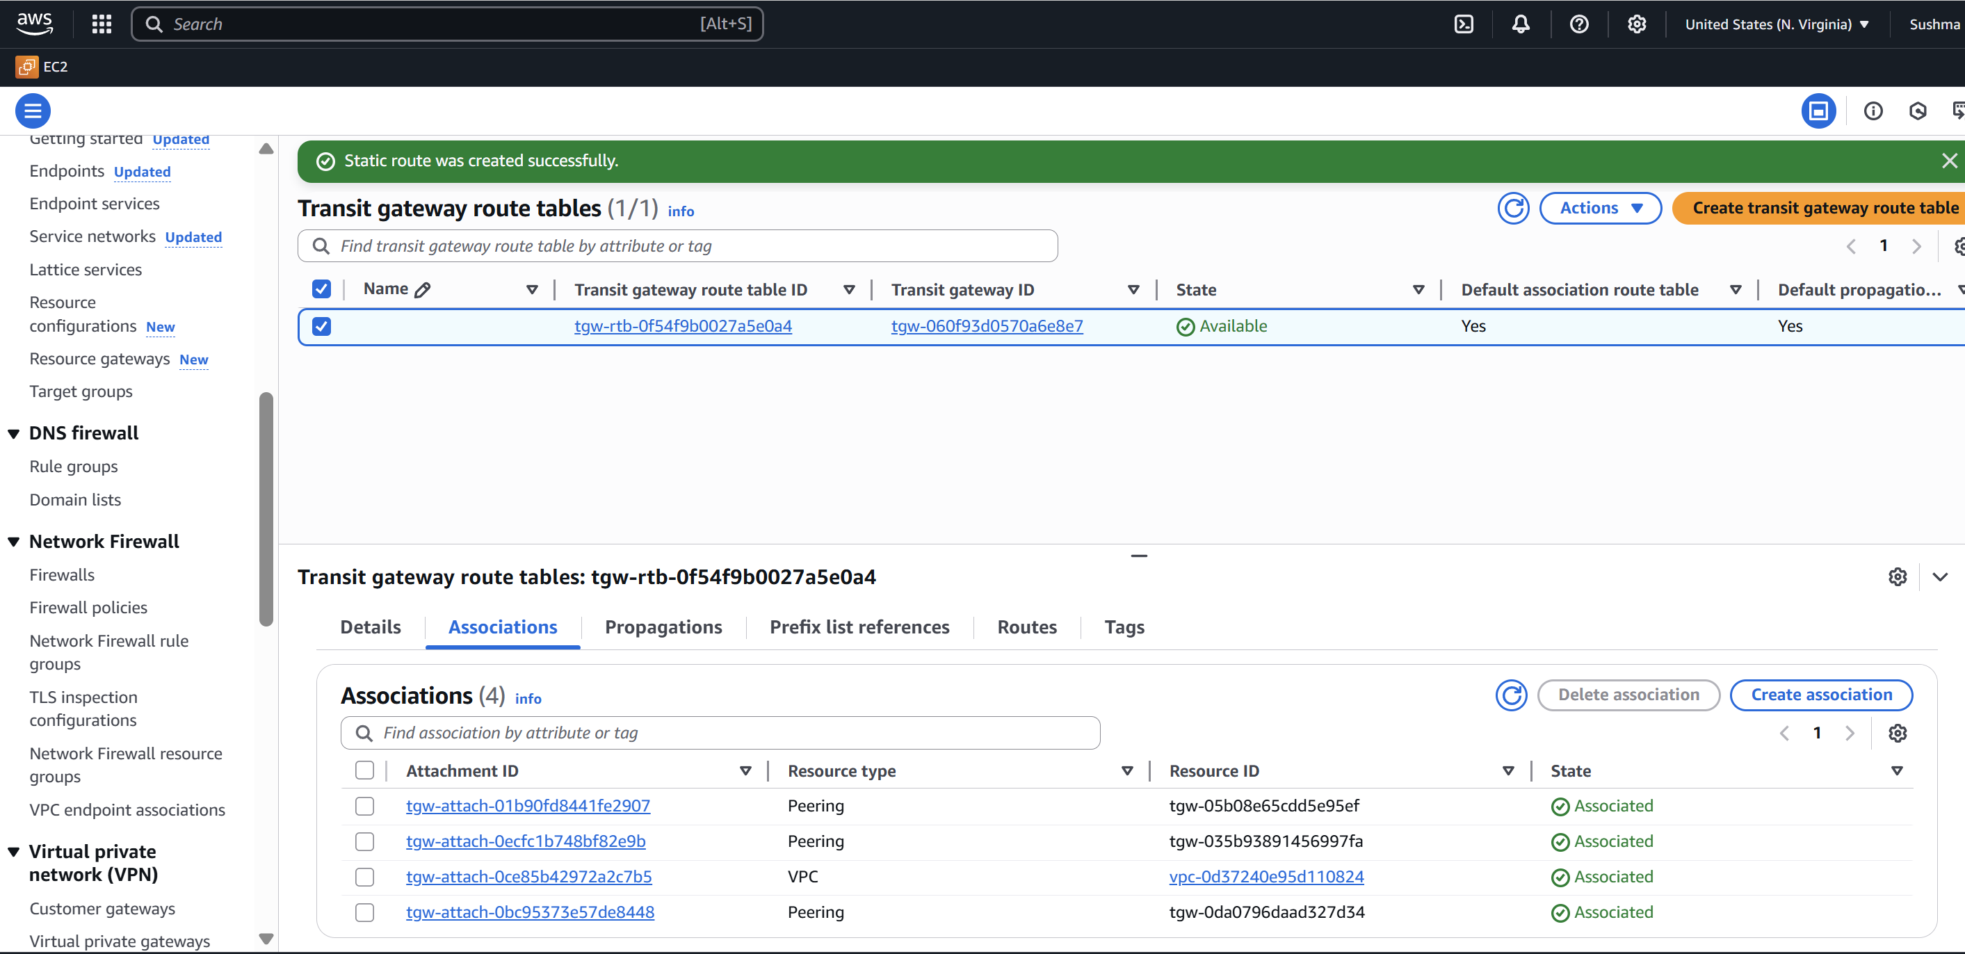

Step 8: Now go to VPC RT and add all 3 Transitgat ways for each 1VPC

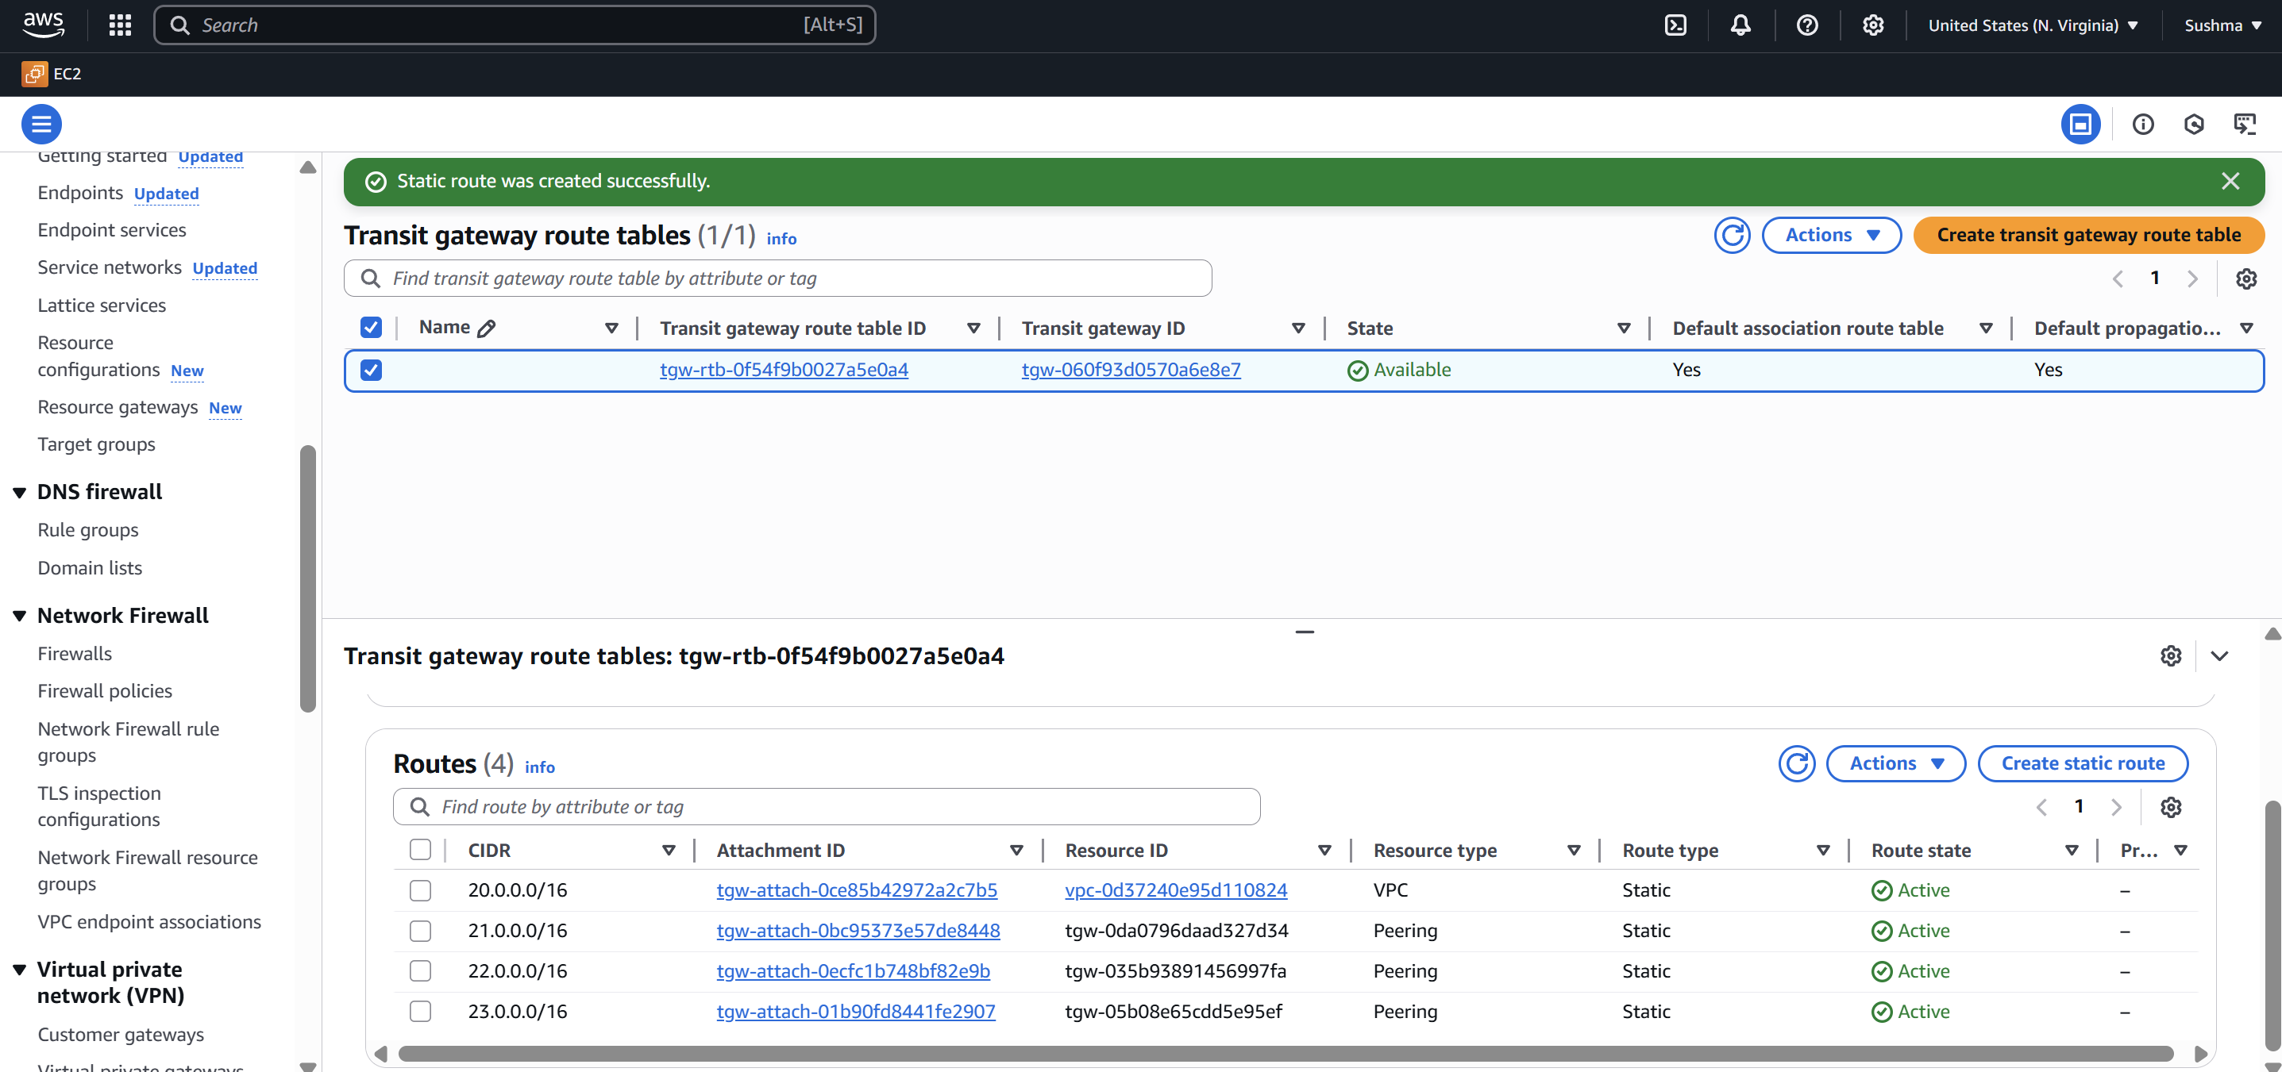

Step 9: Now create 4 EC2’s with respective VPC’s

Here 1st EC2 is connected with Public and remaining are with Private subnets.

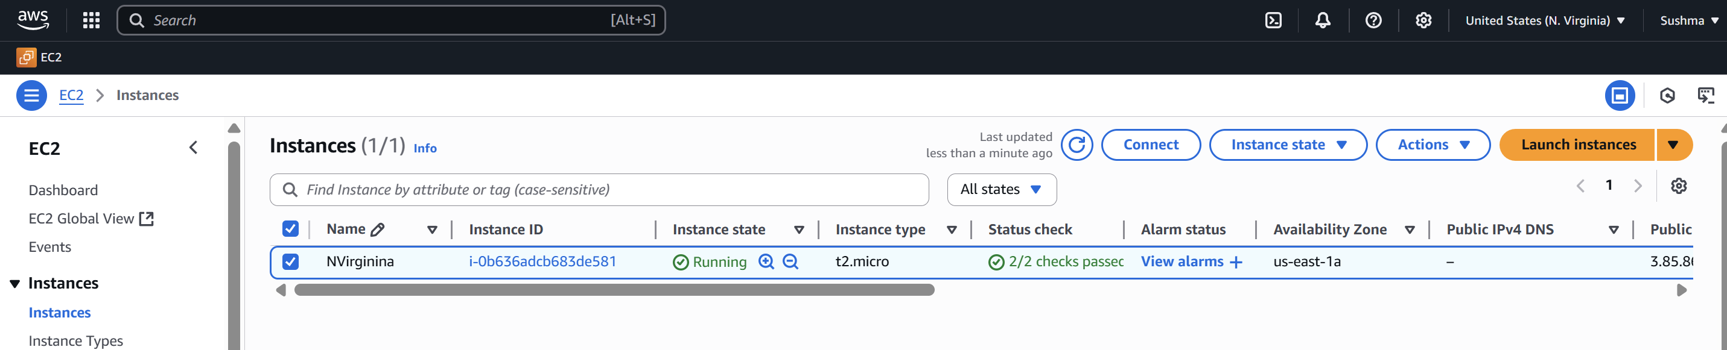

Step 10: Now connect to the 1st ec2 sever then ping with all remaining EC2 Private IP’s

It will connect.s

